SPIRITUALITY IN OUR THIRD THIRTY
AIM: Provide a lesson plan for Church Educators to explore Spirituality with their congregants, especially Older Adults.
MOTIVATION: For older adults, finding one’s spirituality and/or being aware of it from within oneself, is crucial to wellbeing and longevity as one progresses through one’s senior years.
BENEFITS: The activity is relevant to the entire church congregation and provides a means to bring together all ages for a communal intergenerational activity, that would help bridge generational gaps. Younger generations need to be made/kept aware of what their parents and grandparents are experiencing as they age.

NOTE FOR WORKSHOP LEADERS
This material is part of a series of 12 sessions on “The Third Thirty”, addressing how to deal with the challenges of aging so that we are best prepared, as comfortable as possible with the realities, and make this phase of our life the best it can possibly be. The material was developed as part of the OAM Certificate Course sponsored by POAMN under the auspices of the Lifelong Learning Center at Columbia Theological Seminary, GA. More details about “The Third Thirty” and the complete curriculum can be obtained from the creator of “The Third Thirty”, Chris Pomfret, at cjpomfret1954@gmail.com

LESSON PLAN
SETTING: That of a typical Bible Study Group; informal, convivial, sitting around a large table (or in cozy chairs in a lounge setting) so that everyone can see each other. Coffee and/or food available.
OPENING (2 minutes): Start the meeting with a short prayer. Example: Merciful God, we are only too aware of our diminishing abilities as we journey through our Third Thirty of life but we are often not aware of facets that grow within us as we age. Lord, help us to recognize, feel, use and cultivate our spirituality, the elixir of our later life, the source of contentment, happiness, peace and, most importantly, the means by which we can continue to do your work for the rest of our lives. In Jesus’s name we pray. Amen
INTRODUCTIONS AND SCENE SETTING (10 minutes): Pass out copies or have on display the Third Thirty chart (attached) depicting how our spirituality grows when other facets (mental and physical) are diminishing. Explain that spirituality is one of those “abstract” words for which a rigid definition is hard to pin down. We all sort of know what it is but, when asked, we can be stuck for words to describe it. Ask the group to think about what spirituality means to them and ask them to be ready to talk about it later. Even the dictionary struggles (see attached). Pass a copy of the definitions (attached) to each participant and then go round the room asking participants in turn to read the next one on the list.
MAIN PART:
1. (10-15 minutes) Ask the group, “WHAT DOES SPIRITUALITY MEAN TO YOU?” Participants can shout out at random (usually better than going round the room and putting everyone on the spot) Capture all the responses on a whiteboard. Look at the possible groupings of words. Which words were familiar/expected? Were there any that were unexpected/unusual?
2. (10-15 minutes) Ask the group, “IS SPIRITUALITY DEPENDENT ON A STRONG FAITH”? If there is initial reticence to answer, the leader can perhaps offer a perspective that it is not dependent on a strong faith and look for push-back or people’s empathy with such a perspective.
3. (10 minutes) Now look at some bible verses (attached); there might be others that you want to include. Ask the group whether any of these help the group to better understand spirituality? Why?

SUMMARY: (15 minutes). Suggest that we’ve witnessed several different ways of explaining spirituality and that it’s perhaps an even more mysterious word than we realized prior to the discussion! The input from participants during the discussion will likely feed into the following two ways (“elemental” and “human /physiological”) of breaking down Spirituality. However, this proposed framework can also be adjusted by leaders “on the fly” depending what’s been specifically expressed by participants.

An “elemental” breakdown of spirituality might be:
- Being at Peace with our mortality
- Practicing Forgiveness
- Effective Mentorship
- Leaving a Legacy
- Harvesting our Lives
- Appreciating/Valuing Life
From a human/physiological perspective, spirituality could be broken down as follows:
CONTEMPLATIVE/MENTAL
- Gratitude; inward recognition of the world in which we live: the awe, wonder, mystique of it all
- Mindfulness; an awareness of the present, people, and the situation that we find ourselves in at any time
- Peace; with our thoughts and beliefs and the finite nature of our life and our ultimate death
- Realism; acceptance of who we are: our age, condition, blemishes, strengths
OVERT ACTION/PHYSICAL
- Appreciation; outward gratitude to others who do good acts, as well as to our earthly surroundings
- Generosity; giving forward, giving back and giving to
- Openness; listening to others and hearing differing views to our own
- Respect; showing civility, acceptance, compassion
- Love; to include forgiveness of self and others and showing friendship to strangers and friends alike

CLOSING: (2 mins)
Ask a member of the group to offer a closing prayer or, if there are no volunteers, a suggested prayer is: “Good and gracious God, through our participation in today’s discussion, You have revealed so much to us that we didn’t see within ourselves and in your world. Help us to be permanently mindful of our spirituality, to feel its presence within us throughout our daily lives and to practice simple actions, mental, physical and emotional, to make our lives and those of others the best they can be”.
ATTACHMENTS
THIRD THIRTY CHART; Our life can be looked at in simple terms as 3 phases. In the first phase, we rapidly develop, mentally and physically, whereas in the second phase, we typically utilize and build upon those developments and put our abilities to good use in work, family and recreation. The final phase (our Third Thirty) is in essence a reverse of our first thirty so we can realistically expect to see a large number of similarities to the first, with the exception that we have lived a full life, have gathered life experiences and wisdom that we don’t have when we are young. Despite our understandable reluctances to see our aging as something to look forward to, we nonetheless do ourselves a great favor, and also our loved ones, if we can face he realities of growing older and be at peace with those realities, which will be different for us all. This is where spirituality is our best asset ad has been growing within us, all through our lives, whether we know it or not. This “good news” (the upward spiritual growth curve) came from the Rev. Dr. Nancy Copeland-Payton who gave the keynote speech at POAMN’s 2014 conference. Dr. Nancy Copeland-Payton is a spiritual director and ordained clergywoman in the Presbyterian Church (USA). She is author of The Losses of Our Lives: The Sacred Gifts of Renewal in Everyday Loss. A pastor, hospital chaplain and physician who practiced medicine for twenty years, she now leads retreats at church centers, monasteries and with church groups to help people explore their experiences of loss.
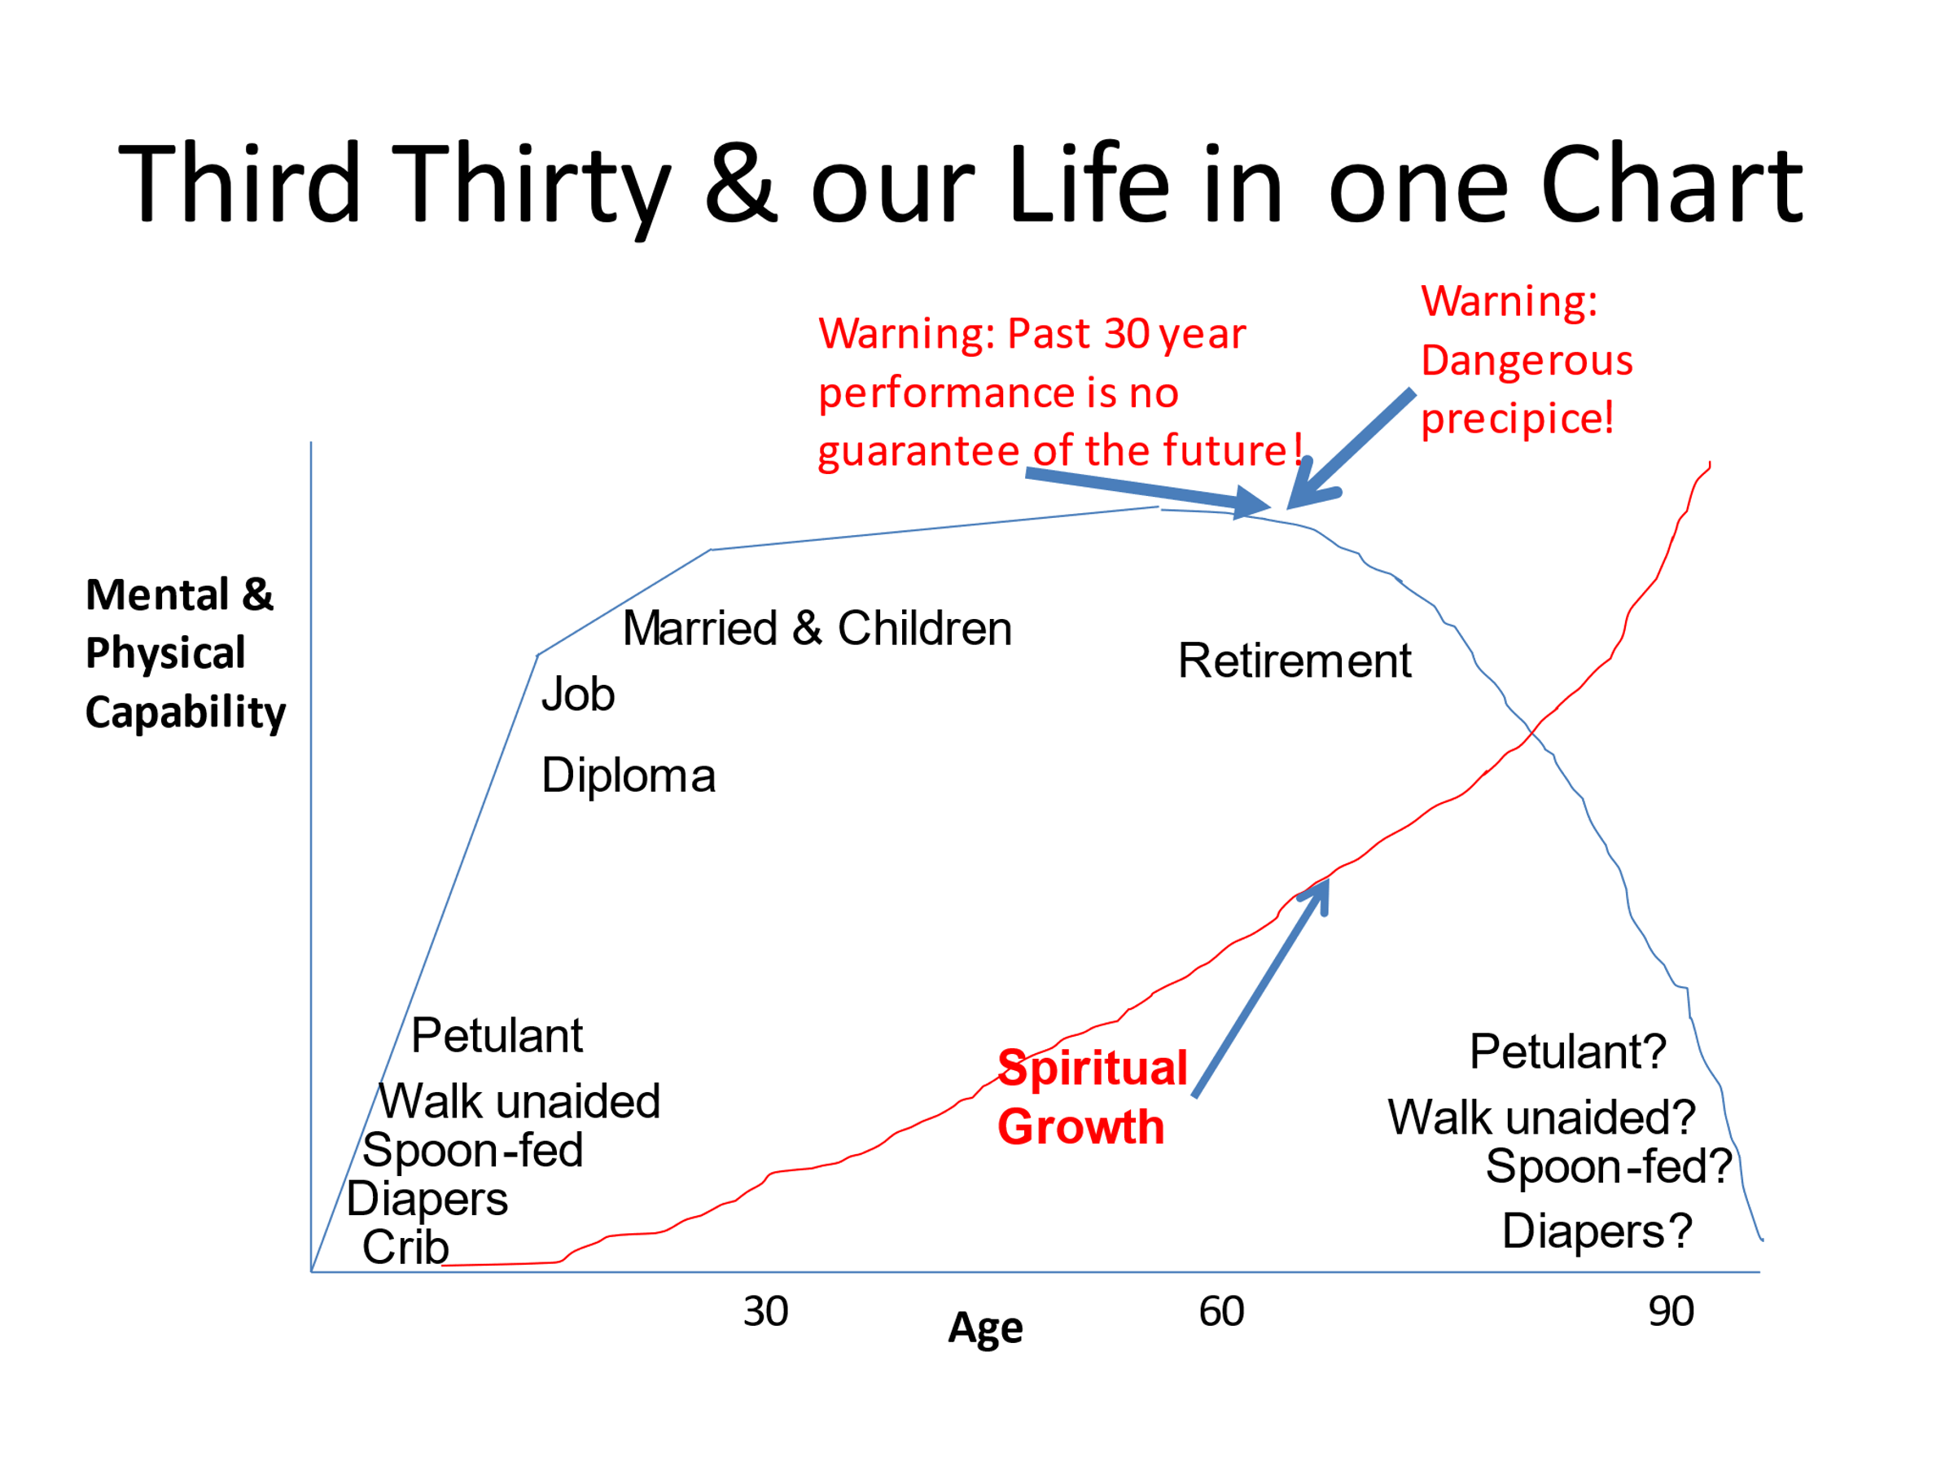

DICTIONARY DEFINITIONS:
Spirit (noun); 14 different definitions in Websters! None of much use to us; nearest are
- Breath
- A supernatural being or essence
- An animating of vital principle held to give life to physical organisms
- A malevolent being that enters and possesses a human being
- The immaterial intelligent or sentient part of a person
- The activating or essential principle influencing a person
In good spirits (lively or cheerful) or out of spirits (gloomy or depressed frame of mind)
Spirit (verb)
- To carry off secretly or mysteriously
Spiritual (adj)
- relating to, or consisting of, spirit
- of, or relating to, sacred matters
- concerned with religious values
- of, or relating to, supernatural beings
- of, relating to, or involving spiritualism
Spiritual (noun)
- things of a spiritual, ecclesiastical or religious nature
Spiritualism (noun)
- The view that spirit is a prime element of reality
- A movement comprising religious organizations emphasizing spiritualism
Spirituality (noun)
- Something that in ecclesiastical law belongs to the church or a cleric of such
- Sensitivity or attachment to religious values
- The quality or state of being spiritual
Spiritualize (verb)
- To make spiritual; to purify form the corrupting influences of the world
- To give a spiritual meaning to or understand in a spiritual sense

BIBLE VERSES:
Galatians 5:22-23 ESV But the fruit of the Spirit is love, joy, peace, patience, kindness, goodness, faithfulness, gentleness, self-control; against such things, there is no law. (Layman’s translation: We know what’s good and proper, let’s be mindful of these things and do them)
Psalm 1:1-3 ESV Blessed is the man who walks not in the counsel of the wicked, nor stands in the way of sinners, nor sits in the seat of scoffers; but his delight is in the law of the Lord, and on his law he meditates day and night.
He is like a tree planted by streams of water that yields its fruit in its season, and its leaf does not wither. In all that he does, he prospers. (Layman’s translation: Have the courage to be yourself)
1 Cor 4:1 Think of us this way, as servants of Christ and stewards of God’s mysteries. (Layman’s translation: Be conscious of and embrace the mystery of life)
1 Cor 12:5 GNV There are many ways of serving, but the same God is served. There are different abilities to perform service but the same God gives ability to each of us. The Spirit’s presence is shown in some way in each person for the good of all. (Layman’s translation: Be aware of our talents and find the power within ourselves to exercise them)

SUGGESTED COMPONENTS OF SPIRITUALITY.
Physical: maintaining a level of healthy physical activity from which the other 2 components are fed
Mental: Consciously positive, and confident that things in life happen for a reason
Emotional: How you feel about yourself, life, the world, the country. Finding a positive meaningful frame of mind.

THE KEY INGREDIENTS FOR COMPLETE SPIRITUALITY
CONTEMPLATIVE/MENTAL
Gratitude; inward recognition of the world in which we live: the awe, wonder, mystique of it all
Mindfulness; an awareness of the present, people, and the situation that we find ourselves in at any time
Peace; with our thoughts and beliefs and the finite nature of our life and our ultimate death
Realism; acceptance of who we are: our age, condition, blemishes, strengths
OVERT ACTION/PHYSICAL
Appreciation; outward gratitude to others who do good acts, as well as to our earthly surroundings
Generosity; giving forward, giving back and giving to
Openness; listening to others and hearing differing views to our own
Respect; showing civility, acceptance, compassion
Love; to include forgiveness of self and others and showing friendship to strangers and friends alike

